Unified Portfolio
Data Analytics | AI | Automation | Computer Vision | ETL | Forecasting
A showcase of selected projects, built for portfolio presentation.

Prepared by ShazilAhmed Shaikh | DEVCORE
Professional Summary
I build practical, end-to-end data and AI solutions that combine clean interfaces, automated pipelines, and decision-support analytics. My work covers dashboards, machine learning prototypes, forecasting notebooks, web automation, and cloud ETL workflows. The common thread across these projects is turning raw data into something usable, visual, and reliable.
Core Strengths
- LLMs, RAG, Reinforcement Learning, Vector DB
- Python automation, scraping, and computer vision
- Dashboard development and data visualization
- Machine learning and forecasting workflows
- AWS ETL, data integration, and reporting pipelines
- Backend integration, APIs, and deployment-ready structure

Selected Projects at a Glance
Project | Focus | Main Stack | Portfolio Value
Berkana AI | Financial intelligence chat system | Flask, PostgreSQL, LLMs, Vector DB, forecasting | AI product design
BiPOP | Translational immunology platform | Flask, XGBoost, Three.js, RDKit | Advanced ML architecture
SI3 Analytics Dashboard | Growth and email analytics | Next.js, Express, MongoDB, Docker | Full-stack analytics
Customer Churn ETL | AWS reporting pipeline | AWS S3, Glue, Athena, Power BI, Airflow | Cloud data engineering
Work Hour Calculator | Computer vision Employee Working Hour Calculator | Python, OpenCV, MediaPipe, TensorFlow | AI, Computer Vision
Demand Forecasting | Retail sales prediction | XGBoost, SARIMA, LSTM, Prophet | Model comparison
Google Maps Scraper | Business data extraction automation | Playwright, pandas, Azure VM, Linux, rclone | 24/7 Scraping, Deployed on Azure VM

SI3 Analytics Dashboard
A full-stack analytics platform for tracking LinkedIn growth and email campaign performance in one place.
Key Highlights
- Interactive LinkedIn and email analytics views with KPI cards and trend charts.
- Excel/CSV upload workflow for analytics ingestion and refresh.
- Dockerized deployment structure for repeatable local or production-style runs.
Tech Stack
Next.js, React, TypeScript, Chart.js, Node.js, Express, MongoDB, Multer, Axios, Docker
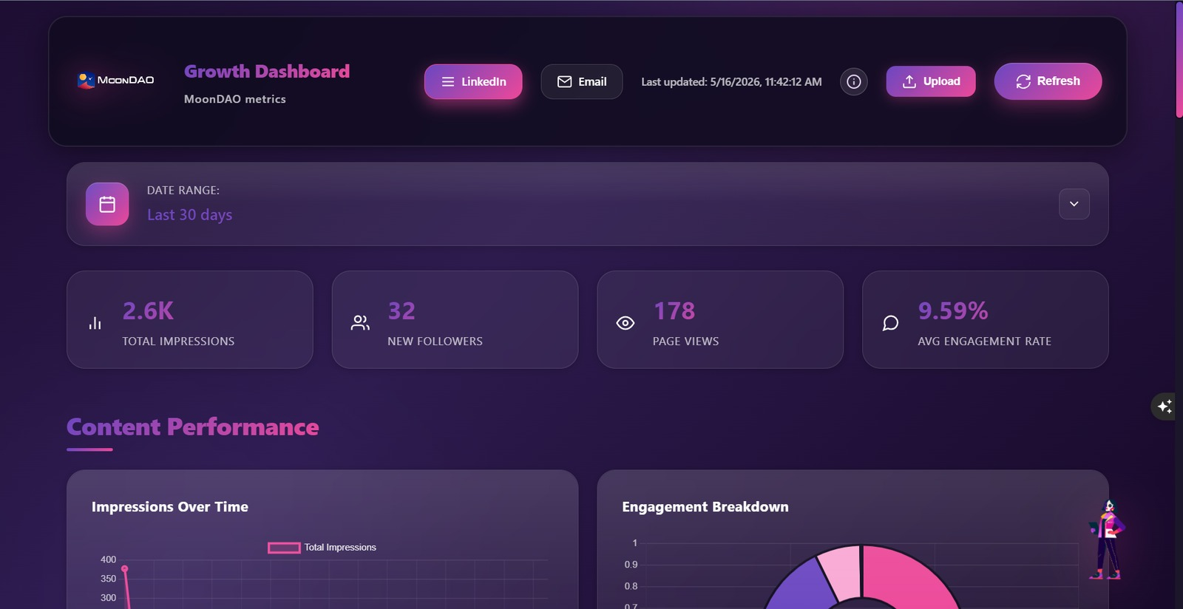  Dashboard overview | 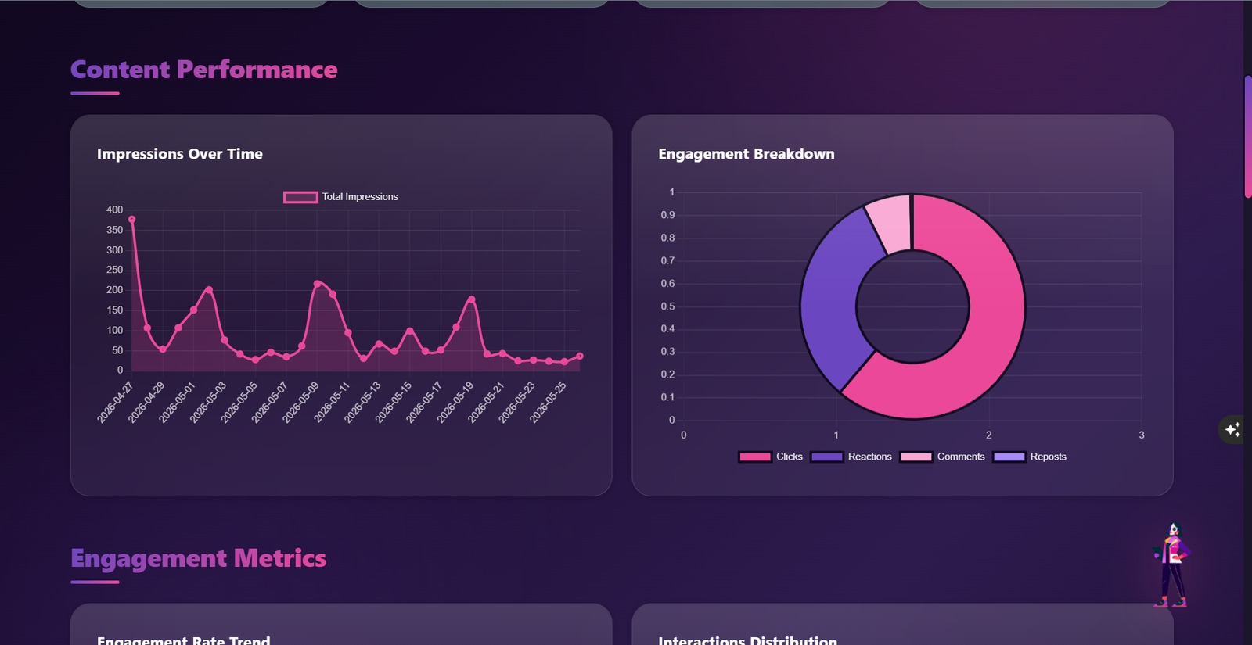  Content and engagement analytics

Work Hour Calculator
A webcam-based computer vision prototype that classifies whether an employee is working or not working and logs time spent in each state.
Key Highlights
- Uses MobileNet-SSD for person detection and MediaPipe for landmark extraction.
- TensorFlow model predicts working versus not_working from a short frame sequence.
- Durations are written to CSV for simple downstream reporting.
Tech Stack
Python, OpenCV, MediaPipe, TensorFlow/Keras, CSV logging
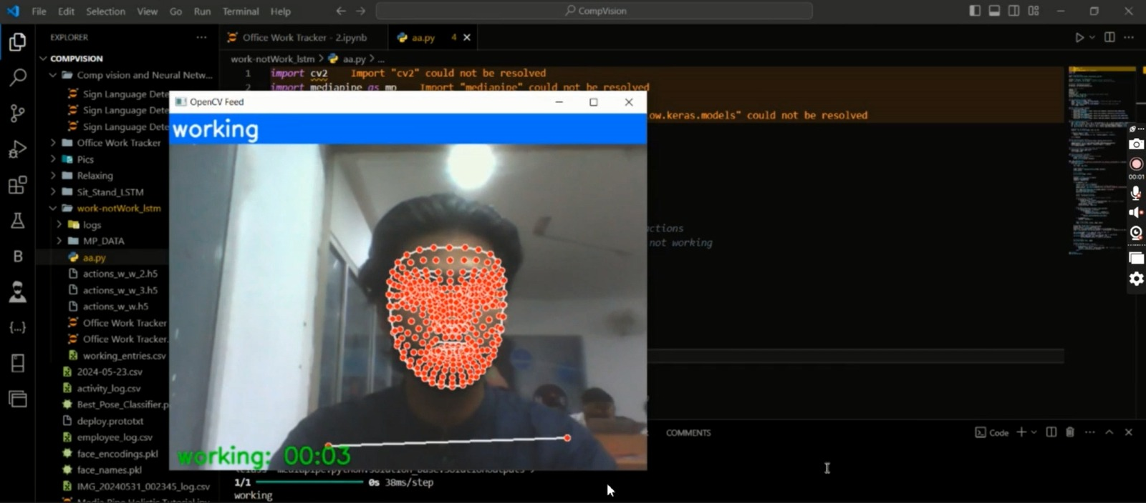
Live working-status detection

Berkana AI
An AI-powered financial intelligence platform with chat, memory, market data, sentiment analysis, and forecasting.
Key Highlights
- Combines a Flask web app with chat sessions, login, preferences, and history management.
- Integrates LLM responses, market/news collection, and vector-style memory search.
- Includes forecasting outputs, charts, and a strong focus on confidence and safety controls.
Tech Stack
Flask, PostgreSQL, pgvector-style memory, SpaCy, FinBERT, LLM APIs, XGBoost/LSTM
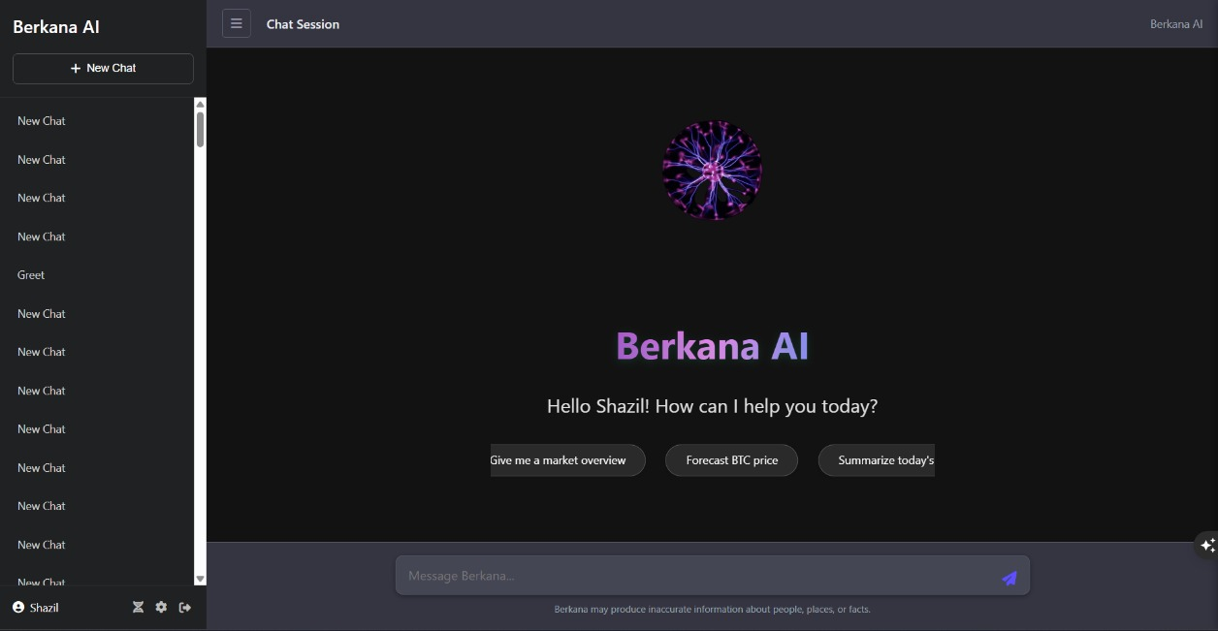  Chat interface | 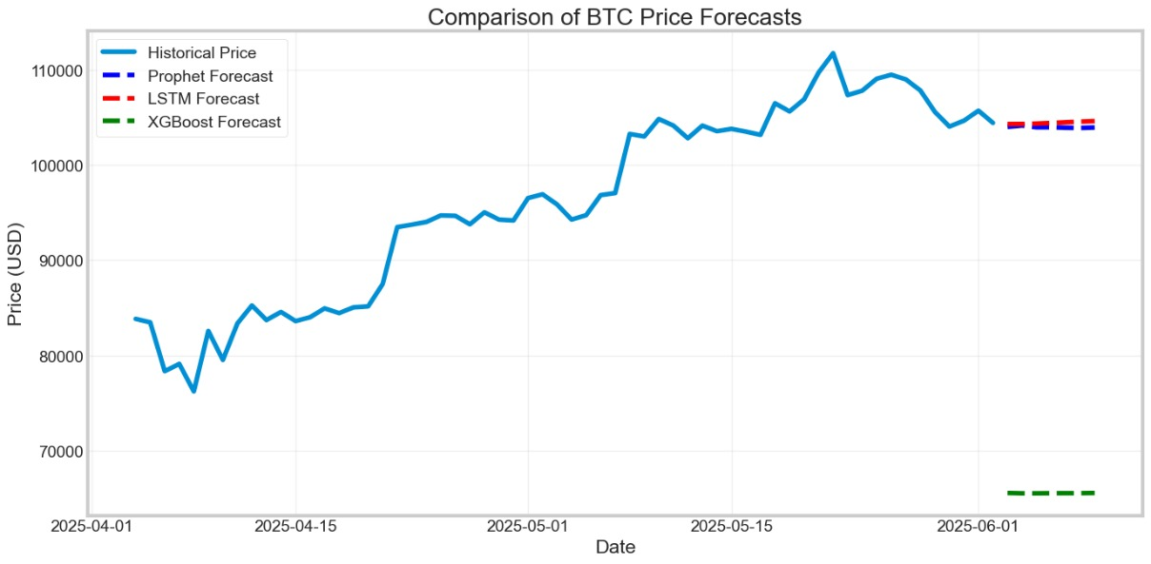  Forecasting and intelligence views

BiPOP
A translational immunology platform that predicts systemic biological effects and supports reverse design workflows.
Key Highlights
- Maps perturbations into organ-level outcomes using scoring, translation, and fit engines.
- Includes 3D BidirBody visualization for systemic prediction and interpretation.
- Combines Flask APIs, XGBoost models, and cheminformatics checks for a complete workflow.
Tech Stack
Flask, XGBoost, Three.js, RDKit, Pandas, NumPy, Gunicorn
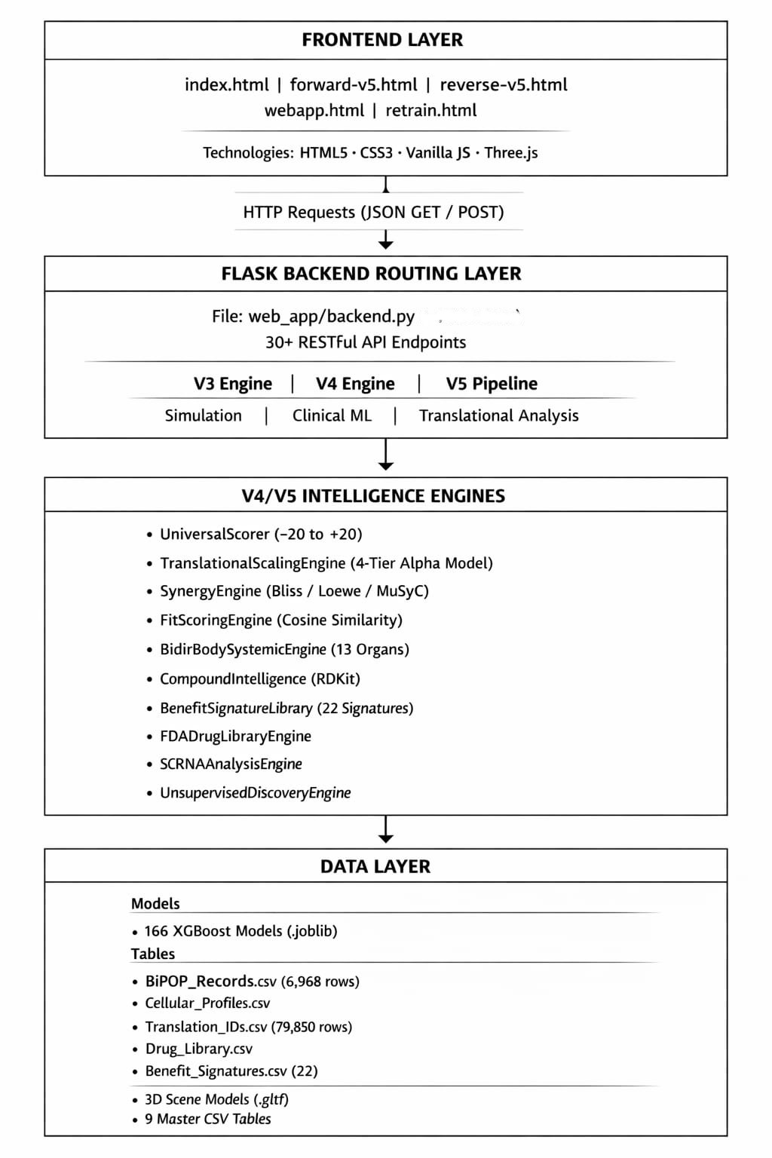
System architecture overview

Customer Churn ETL Dashboard
A cloud ETL and reporting pipeline that prepares churn data for Power BI through AWS services and automation.
Key Highlights
- Uses S3, Glue crawlers, Glue jobs, and Athena to transform and query data.
- Connects to Power BI through ODBC for a clean reporting layer.
- Airflow orchestration supports scheduled and recoverable pipeline execution.
Tech Stack
AWS S3, AWS Glue, Amazon Athena, Power BI, Apache Airflow, Python
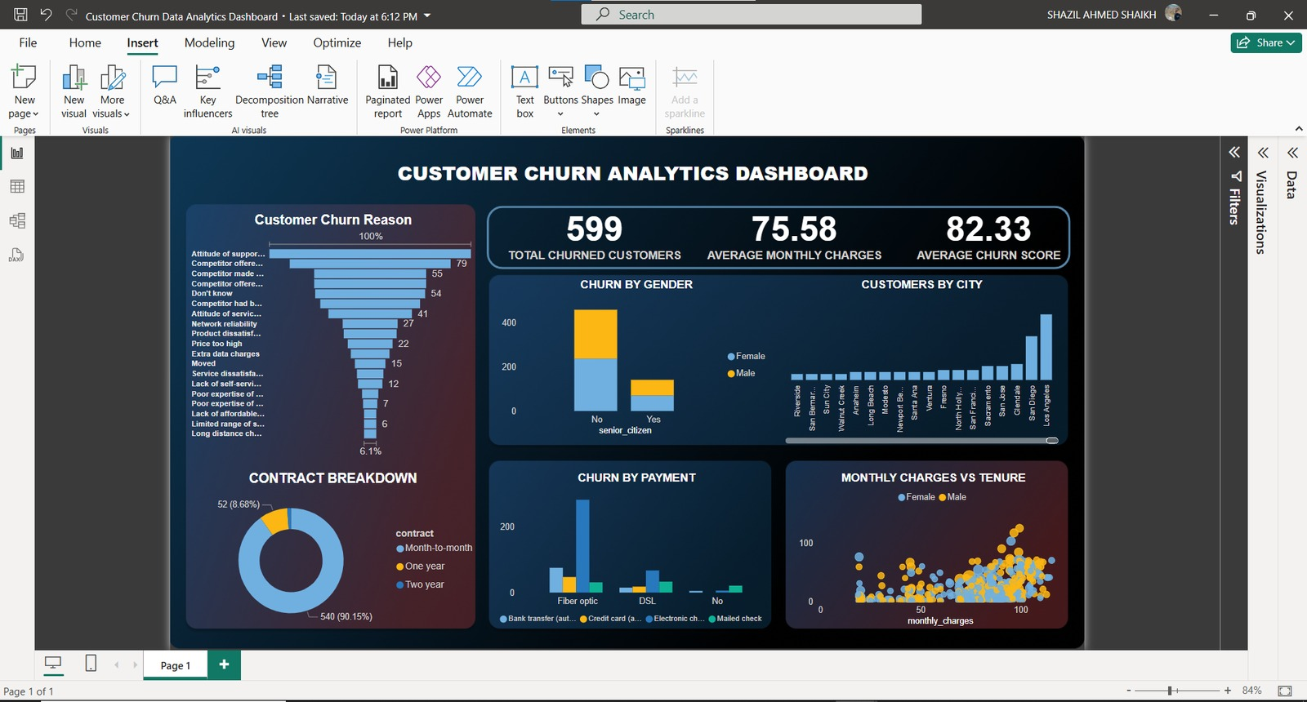  Power BI dashboard | 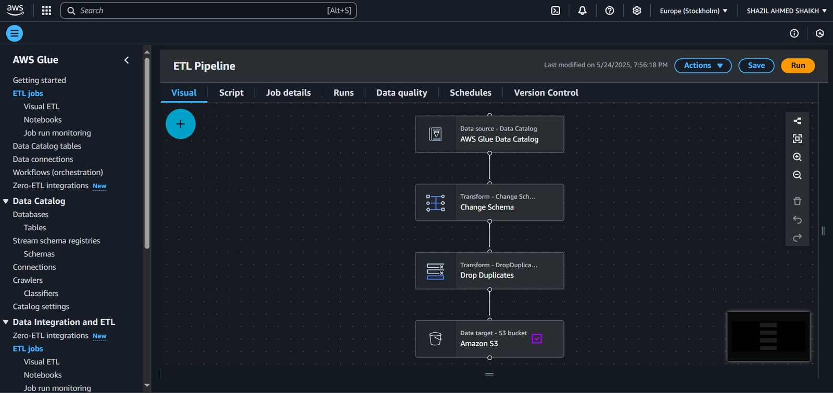  AWS pipeline and catalog

Demand Forecasting Notebook
An end-to-end retail forecasting study for Walmart weekly sales, covering analysis, feature engineering, and model comparison.
Key Highlights
- Explores seasonality, holidays, store types, and macro variables with clear visual analysis.
- Compares XGBoost, SARIMA, LSTM, and Prophet across the same problem.
- Shows how classical time-series and ML methods can be evaluated side by side.
Tech Stack
Python, pandas, matplotlib, XGBoost, SARIMA, LSTM, Prophet
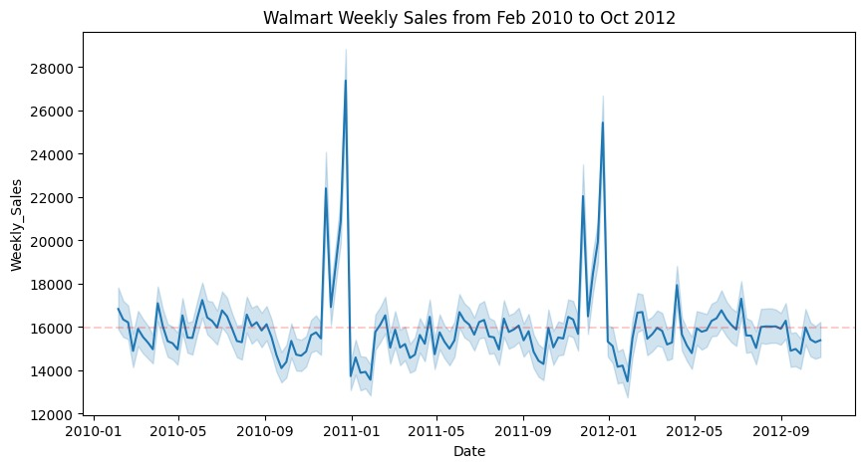  Weekly sales trend | 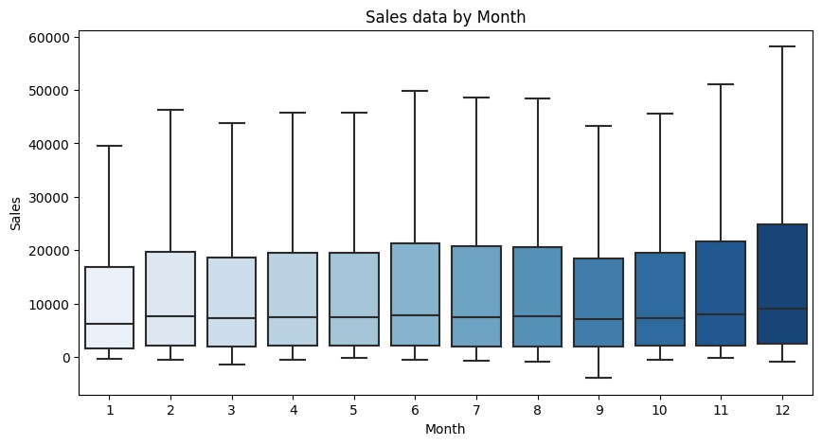  Seasonal sales comparison

Google Maps Business Scraper
A Playwright-based scraping system for extracting business listings, reviews, images, and contact details at scale.
Key Highlights
- Includes retry logic, progress tracking, and browser health recovery.
- Exports structured CSV files and synchronizes results to Google Drive with rclone.
- Designed for multi-city or multi-state scraping with robust recovery support.
Tech Stack
Python, Playwright, pandas, threading, rclone, CSV pipelines
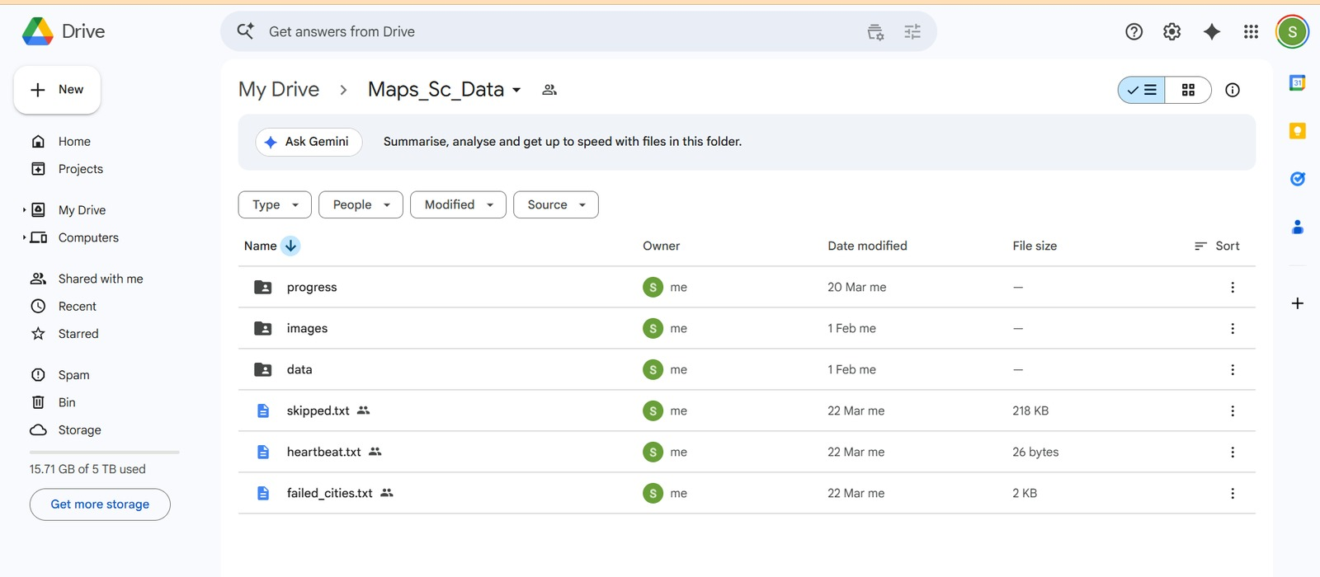  Cloud backup and sync | 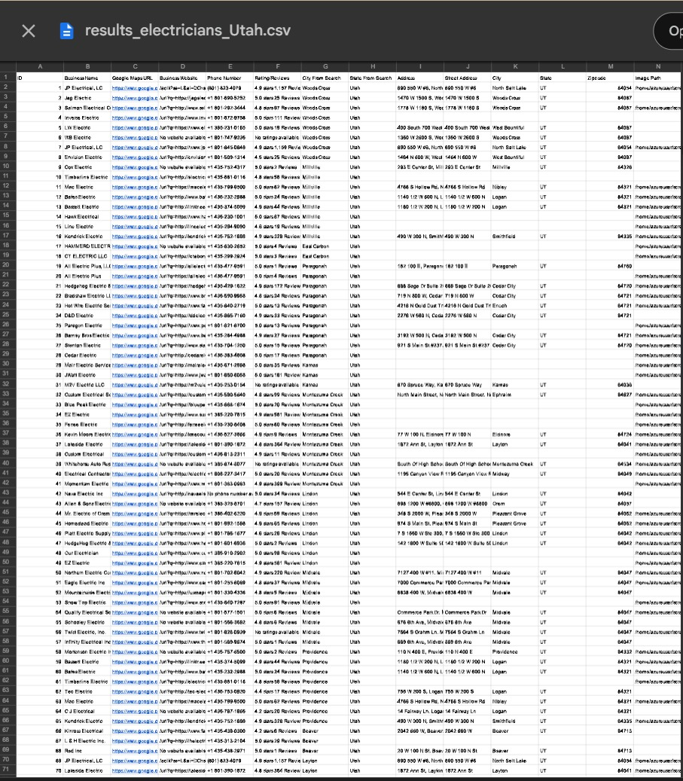  Scraped business results

Closing Note
This portfolio brings together projects across analytics, AI, cloud data engineering, forecasting, and automation. Each project was selected to show a different strength: practical problem solving, clean implementation, and the ability to deliver work that is both technical and presentation-ready.
End of portfolio

